Second Grade Supply List
2019-2020
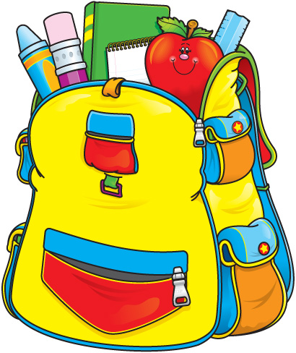

7 journals (marble composition books)
3-prong, 2-pocket plastic folders, 1 of each color: red, yellow, green, blue, orange, purple
2 packages wide-ruled notebook paper
6 packages of pencils (pre-sharpened) **NO MECHANICAL PENCILS.**
1 pack page protectors
Pink Pearl Erasers (large)
2 Boxes of crayons (24 ct.)
Glue sticks only (4)
Scissors (blunt style)
Zip-loc bags (gallon)
Kleenex (at least 3 packs)( No personal sized packages.)
Paper towels (at least 2 packs)
Hand soap
Baby Wipes
Post its
Large hand sanitizer (No personal sized packages.)
1 set of ear buds to keep at school for use in computer lab. Please purchase ear buds as we do not have room to store large headphones.
No pencil pouches or boxes.

